DEPARTMENT OF BOTANY:

EXTENSION LECTURE BY G. SURENDER REDDY GARU, SRBGNR COLLEGE, KHAMMAM.

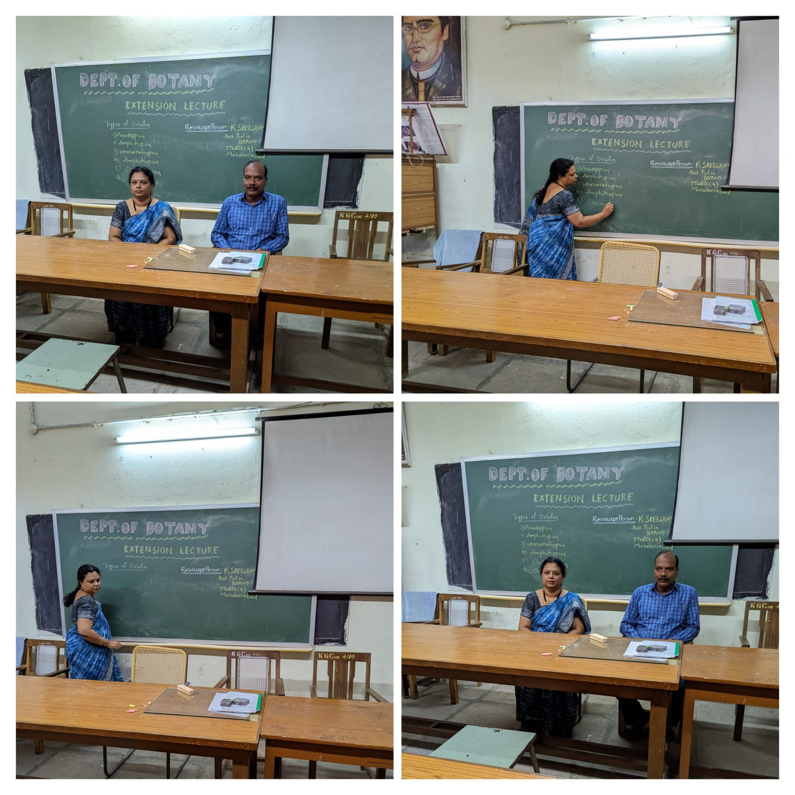

DEPARTMENT OF CHEMISTRY:

EXTENSION LECTURE BY Dr.V.SHANTI KUMAR SIR, ASSISTANT PROFESSOR OF CHEMISTRY SRBGNR COLLEGE KHAMMAM.

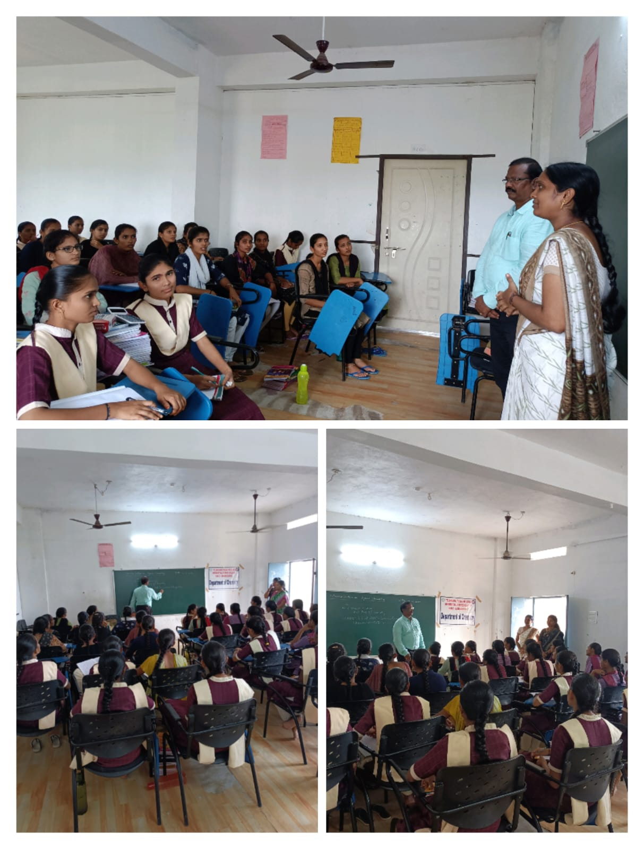

DEPARTMENT OF COMPUTER SCIENCE:

EXTENSION LECTURE BY 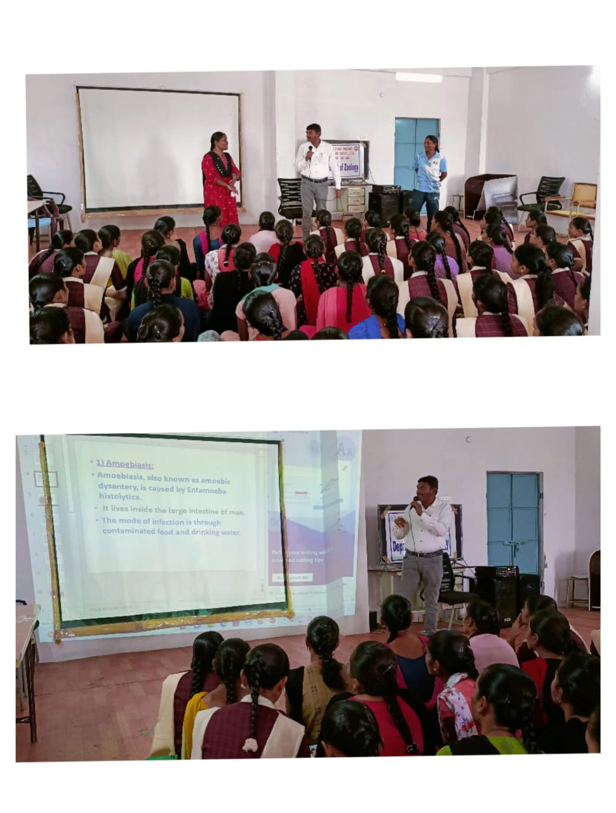

DEPARTMENT OF HISTORY:

EXTENSION LECTURE BY

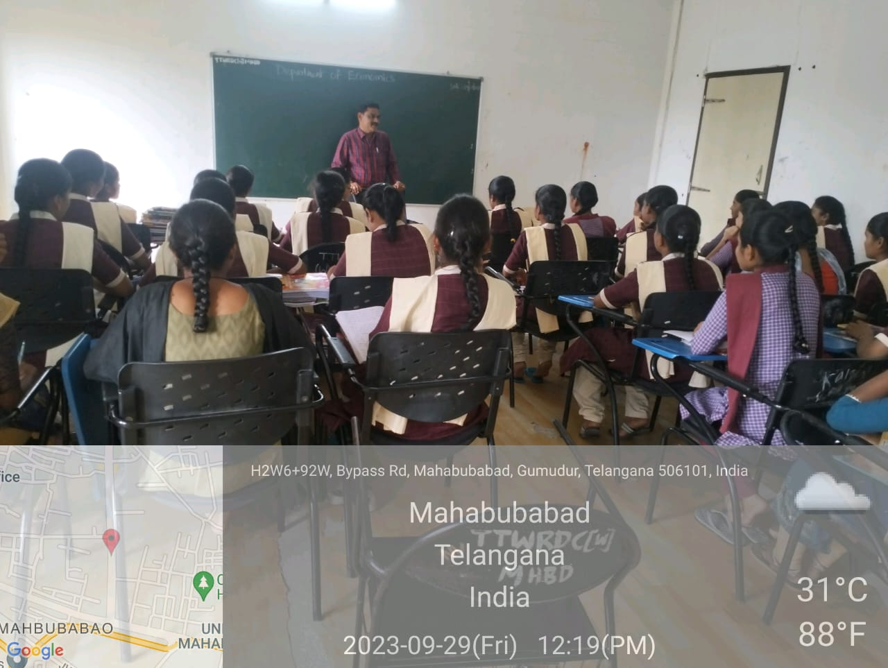

DEPARTMENT OF TELUGU:

EXTENSION LECTURE BY Assistant professor Dr.GADDAM MOHAN RAO (DEPARTMENT OF TELUGU TELANGANA MAHILA UNIVERSITY)

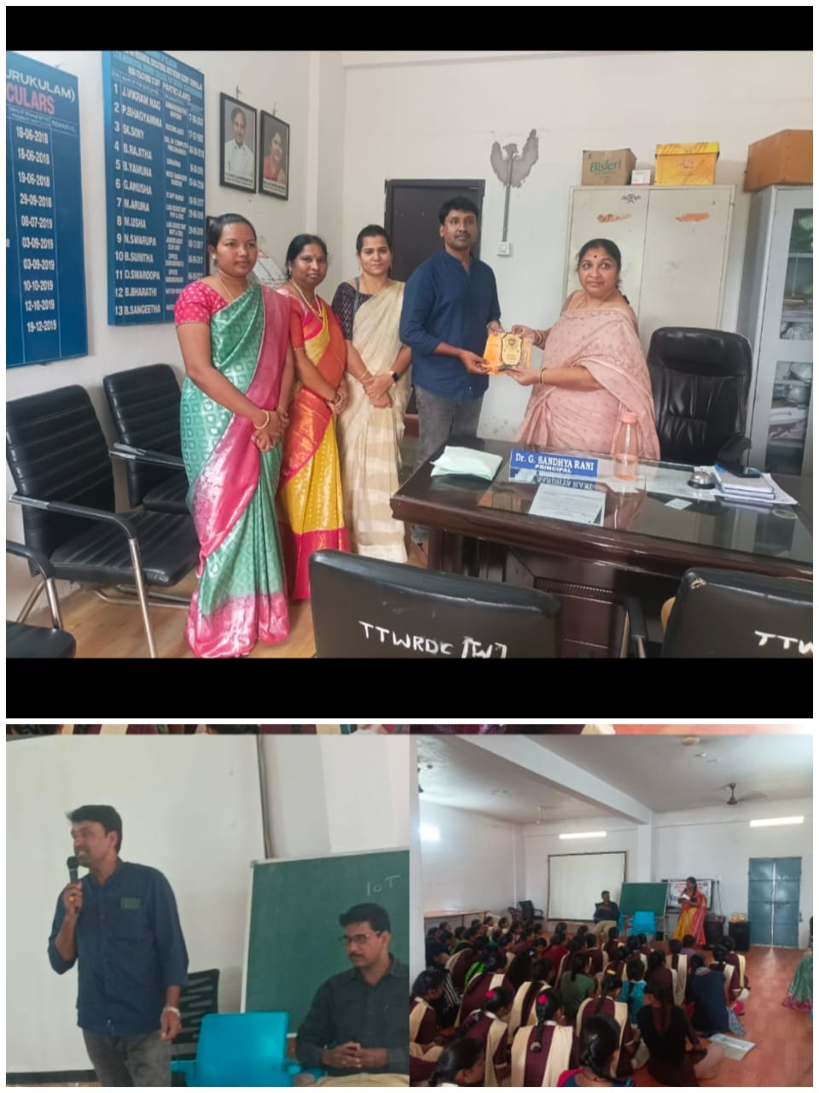

DEPARTMENT OF STATISTICS:

EXTENSION LECTURE BY Dr.S.RAMESH SIR, ASSISTANT PROFESSOR OF COMMERCE SRBGNR COLLEGE KHAMMAM.

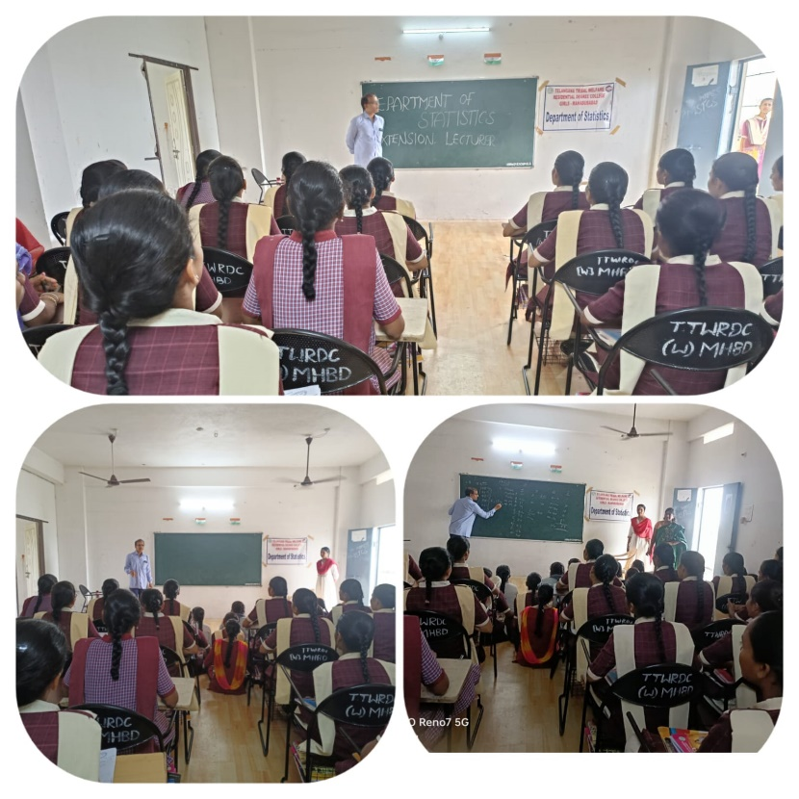

DEPARTMENT OF HISTORY:

EXTENSION LECTURE BY B.VENKATESHWARLU SIR DEVELOPMENT OFFICER.

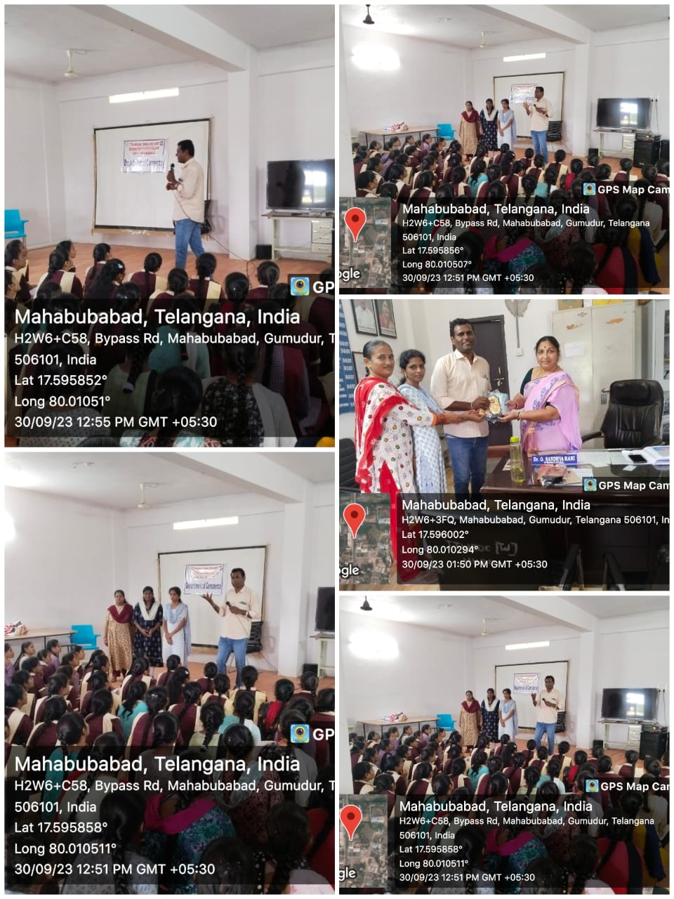

DEPARTMENT OF ENGLISH:

EXTENSION LECTURE BY P.RAM REDDY ASSISTANT PROFESSOR OF ENGLISH, GOVERNMENT DEGREE COLLEGE MAHABUBABAD.

